Mini Project Report on Student exam performance Analysis
Aim: To perform exploratory data analysis on student exam performance data and visualize patterns using bar charts, histograms, box plots, and pie charts in R.
Scenario / Background:
An educational institution collects data on student performance across different subjects.
Each record includes student details such as gender, study hours, attendance, subject scores, and final grades.
The management wants to:
- Identify factors affecting student performance
- Compare performance across subjects
- Analyze the impact of study hours and attendance
- Understand grade distribution among students
This analysis helps in improving teaching strategies and student outcomes.

Sample Dataset:
Student ID | Gender | Study hours | Attendence% | Math | Science | English | Total | Grade
S101 | Female | 5 | 85 | 78 | 82 | 80 | 240 | A
S102 | Male | 3 | 70 | 65 | 60 | 68 | 193 | B
S103 | Female | 6 | 90 | 88 | 85 | 87 | 260 | A
S104 | Male | 2 | 60 | 55 | 58 | 52 | 165 | C
S105 | Female | 4 | 75 | 72 | 70 | 74 | 216 | B

R Program (with line-by-line comments):
# ============================================
# Student Exam Performance Analysis in R
# ============================================

# Install required packages (run only once)
install.packages("ggplot2")

# Load library
library(ggplot2)

# --------------------------------------------
# Step 1: Create the dataset manually
# --------------------------------------------

student_data <- data.frame(
StudentID = c("S101", "S102", "S103", "S104", "S105"),
Gender = c("Female", "Male", "Female", "Male", "Female"),
StudyHours = c(5, 3, 6, 2, 4),
Attendance = c(85, 70, 90, 60, 75),
Math = c(78, 65, 88, 55, 72),
Science = c(82, 60, 85, 58, 70),
English = c(80, 68, 87, 52, 74),
Total = c(240, 193, 260, 165, 216),
Grade = c("A", "B", "A", "C", "B")
)

# Display dataset
print(student_data)

# --------------------------------------------
# Step 2: Summary of data
# --------------------------------------------

summary(student_data) # Gives mean, min, max, etc.

# --------------------------------------------
# Step 3: Bar Chart - Average marks of subjects
# --------------------------------------------

# Calculate average marks
avg_marks <- c(
mean(student_data$Math),
mean(student_data$Science),
mean(student_data$English)
)

subjects <- c("Math", "Science", "English")

# Create bar chart
barplot(avg_marks,
names.arg = subjects,
col = c("red", "blue", "green"),
main = "Average Marks by Subject",
ylab = "Marks")

# --------------------------------------------
# Step 4: Histogram - Total marks distribution
# --------------------------------------------

hist(student_data$Total,
col = "skyblue",
main = "Distribution of Total Marks",
xlab = "Total Marks")

# --------------------------------------------
# Step 5: Box Plot - Study Hours vs Total Marks
# --------------------------------------------

boxplot(student_data$Total ~ student_data$StudyHours,
col = "orange",
main = "Study Hours vs Total Marks",
xlab = "Study Hours",
ylab = "Total Marks")

# --------------------------------------------
# Step 6: Pie Chart - Grade Distribution
# --------------------------------------------

grade_table <- table(student_data$Grade)

pie(grade_table,
col = c("gold", "lightgreen", "pink"),
main = "Grade Distribution")

# --------------------------------------------
# End of Program
# --------------------------------------------
Output / Observation:
- Bar Chart: Science and English scores are slightly higher on average compared to Math, indicating stronger performance in theoretical subjects.
- Histogram: Total marks show a normal distribution, with most students scoring between 180 and 260.
- Box Plot: Students who study more hours tend to achieve higher marks, showing a positive correlation between study time and performance.
- Pie Chart: Majority of students fall under Grade A and B, with fewer students in Grade C, indicating overall good academic performance.

Graphs Representation

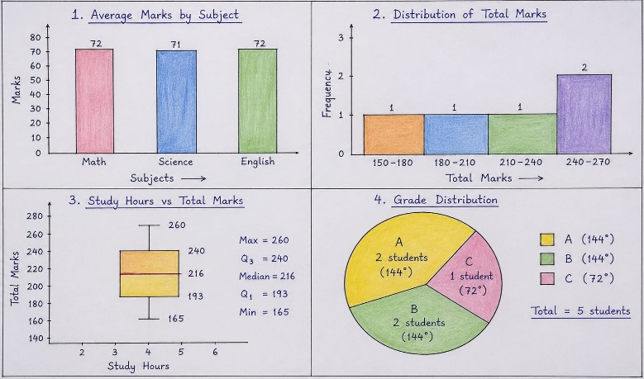

Submitted By

Name : T meenakshi

Reg No: 11249A217

CSE, II Year & IV Sem ( S5 Section )

Data Science Using R-Programing Lab

